**MEASURE OF ENERGY CONSUMPTION**

***Energy consumption of Electrical Vehicle : Analysis of selected parameters Based on Created Database***

**INTRODUCTION**:

* The energy consumption of Electrical Vehicle refers to the amount of energy that is used by the vehicle propulsion system .
* This parameter depends on a number if Vehicle factors, including Vehicle size, weight and aerodynamics ,Vehicle efficiency drivers driving style and driving conditions

**METHODOLOGY**

* The work assumed the analysis of selected parameters of electric vehicles, which can be accessed from basic Vehicle catalog data .
* The selected result parameters are,

1. Release year
2. Acceleration to 100(km/h)
3. Drivetrain type
4. Plug type
5. Price

* The Python programming was used to process these data
* 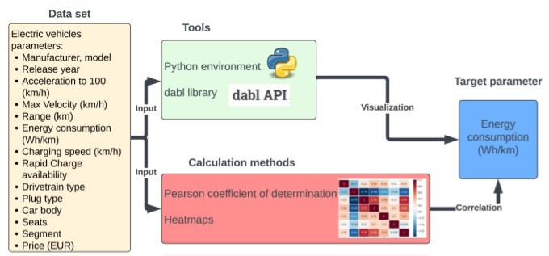***General structure of the work***

**DATA SET:**

* The data set is the important element that contributes to the accuracy of performing data analysis
* The data set Considered was an EV dataset that contained

1. Manufacturer
2. Model
3. Release year
4. Acceleration to 100 (km/h)
5. Max velocity (km/h)
6. Range(km)
7. Energy consumption (Wh /km)
8. Charging speed (km/h)
9. Rapid charge availability
10. Drivetrain type
11. Plug type
12. Car body
13. Segment
14. Number seats
15. Price (EUR)

**DATA PROCESSING:**

* Data processing aims to collecting and manipulating data in order to obtain information from their analysis
* The steps involves
* **Data Collection :** Collection the data set
* **Data cleaning :**Identify and correct incorrect attributes for saved data records
* **Data integration :** Combines data from various sources and prepares the Dara further analysis
* **Data Transformation and Visualization :** It cause data to be properly converted at the beginning to the required specificity of the data format and then Visualization are Created

**FLOW CHART :**

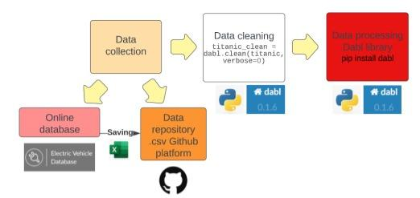

* The selected catalog EV parameters were saved in Excel spreadsheet and the saved as a .csv file , which was imported into the GitHub data repository

**ALGORITHM** :***Data processing of EVs in dabl***

1. Pip install dabl #install dabl package
2. From dabl Import plot # import the plotting tool
3. Import matplot lib . Pip plot #plt # Import the plot tool
4. Import pandas # pd #Importing a library for data analysis
5. Df= pd.read _csv(‘location of EVs data set ‘)#indicate location of EVs data set
6. Df.dtypes # define datatypes for analyst columns
7. Titanic _ clean = dabl .clean (titanic, verbose = 0)#cleaning data
8. Types = dabl . Detect _ types ( titanic _ clean ) # cleaning data
9. Plot ( df , ‘ energy consumption ( Wh/km) ‘ )# creating Visualization

**PROGRAM :**

A program for analysing an energy consumption dataset using Python, following below steps that provides analysing the dataset using the pandas library:

1. **Install Required Libraries:**

pip install pandas matplotlib

2. **Import Libraries:**

Import the required libraries in Python script.

python

import pandas as pd

import matplotlib.pyplot as plt

3. **Load the Dataset:**

Load energy consumption dataset (in CSV format, for example) into a pandas Data Frame.

```python

# Replace 'your_dataset.csv' with the actual filename or URL of your dataset

df = pd.read_csv('your_dataset.csv')

```

4. **Explore the Dataset:**

Explore the dataset to understand its structure and contents.

```python

# Display the first few rows of the dataset

print(df. Head())

# Get basic statistics of the dataset

print(df. Describe())

# Check for missing values

print(df.isnull().sum())

```

5. **Data Analysis and Visualization:**

Perform analysis and create visualizations based on specific requirements. For example, if want to visualize energy consumption over time:

```python

# Assuming your dataset has a 'date' column and an

'energy consumption' column

plt.figure(figsize=(12, 6))

plt.plot(df['date'], df['energy_consumption'], marker='o', color='b', label='Energy Consumption')

plt.xlabel('Date')

plt.xlabel('Energy Consumption')

plt.title('Energy Consumption Over Time')

plt.legend()

plt.xticks(rotation=45)

plt.tight_layout()

plt. Show()

```

**RESULTS OF DATA ANALYSIS :**

* The dabl tool imported input files for the data records under study with the target parameter, which was energy consumption.
* 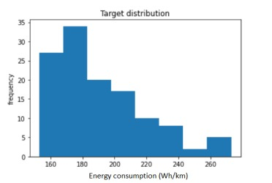The data distribution for the energy consumption parameter is shown below